Development Environment Setup

* Install NodeJS
* Install NPM(Node package manager)
* Install Angular CLI globally (npm install -g @angular/cli)

What is Node.JS?

It is a javascript runtime built on chrome V8 javascript engine.

Node.jS uses an event driven,non blocking I/0 model that makes it lightweight and efficient.( if two C# or asp.net app two concurrent users then there will be slow wait since it is Blocking I/O. But not the NodeJS

Running javascript outside browser

Create a javascript file and run node myfirst.js

What is NPM?

All package will reside here. It is javascript package manager.

Share and resuse code.

Easily install modules/packages on your system

Eg package – bootstrap, jquery,require,angular

Angular Commands

1. Install Angular CLI

npm install -g @angular/cli

CLI can be installed in each folder or globally(g)

1. Install any new packages from NPM

npm install **twit -- save**

package.json – include the package and add the package dependencies.

Npm init

Npm install

NPM Install will install look for packages in your package.json and install packages in node_modules

1. Create a new application

ng new my-app

1. Go to the app

Cd my-app

Ng serve –open

The ng serve command launches the server, watches your files, and rebuilds the app as you make changes to those files.

1. Ng generate component heroes

ng generate component heroes

1. Ng generate module

Ng generate module products/product –flat -m app.module

Will also update app module after creating new module

The CLI creates a new folder, src/app/heroes/ and generates the three files of the HeroesComponent.

1. Create Service in angular
2. Create a service

Ng generate service services/data

My service name is dataservice

1. Import Add to app.module inside the provider
2. Use the service in the component that you are going to use

Import services

Call the dependency injection

Constructor(private dataservice:DataService) {

}

1. Go to the service ts file

Write service methods

(use http module, react module map)

Method() return {This.http.get(‘https://’);)

1. Call the service method in component

Dataservice.dataposts.subscribe(posts)

Map to interface posts

1. Html page -> map the output let posts
2. Routing

Where the routing should rout appropriately.

1. Import the router module and routes from app.module
2. Create our route variable array

Eg: homepage, postspage

1. Import routmodule and add them routes contstant

So routing defined http/ocalhost/about or http:/localhost/post

1. Use them <route-applet> in app.componet.html
2. Version of nodejs installed in your system. And npm version and angular cli version

node -v

npm – v

ng – v

Note you are doing all your working in Angular CLI(Power Shell)

Angular CLI

It is a command line interface for angular

Build and angular application

Generate angular files

Execute the application

Run unit and end to end test

Prepare the application for deployment

1. Do the installation => npm install -g @angular/cli
2. Ng new => ng new helloworldapp
3. Ng serve => listen on 4200. Compiler in watch mode if any changes it will recompile
4. Do help => Ng g- help ng build -help
5. Ng test => karma test runner
6. Ng e2e => using protractor
7. Ng build => the output is similar to ng serve but we will have dist folder created. Dist folder will have all the bundle files + index.html. we can put this in server and deploy our application . This is for regular build

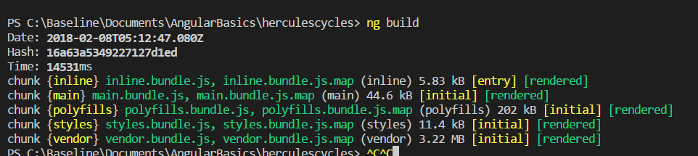

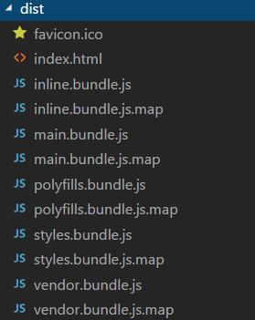

1. Ng build – prod => minify or uglify(small as much), tree shaking (drop out any dead branches), precompile our templates instead of downloading angular compiler as part of vendor bundle and running the compiler in browser we can make the bundle smaller and run faster we can precompile it (Aheade of time compiler(AOT) ng build – prod will do all this for us. And we can deploy this. If you notice in the dist folder the file name has hashcode and this is called cash busting technique.

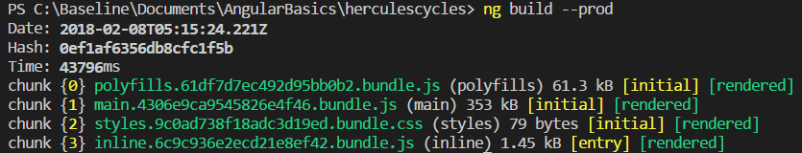

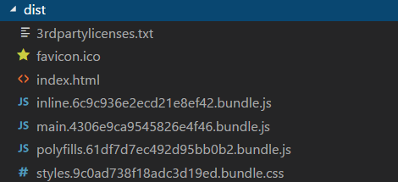

Angular Components and Files

1. Components

Root component => app-root

Each component will have css file, html file, component file, spec file, module file.

1. Readme.md

Commands for ng

1. Src folder

App lives in src folder. Src folder has your angular component, templates,styles,images

1. App component

app/app.componet.css – css

app/app.component.html – html template

app/app.component.ts – template file

app/app.component.spec.ts – unit test file

app/app.module.ts – module tells how to assemble the application

1. Assets/* - images
2. Environmens/* - has one file for each of your environment each has simple configuration variable to use in your application. The files are replaced on the fly when you build the application
3. Favi con.ico – bookmark bar image
4. Index.html – the main html page that serves when someone visits your site Most of the time you'll never need to edit it. The CLI automatically adds all js and css files when building your app so you never need to add any <script> or <link> tags here manually.
5. Main.ts – main entry point for your application. Compiles the application with the JIT compiler and bootstraps the application root module(app module) to run in browser.
6. Polyfills.ts - Different browsers have different levels of support of the web standards. Polyfills help normalize those differences.
7. Style.css – global styles go here this is central styles
8. Test.ts – main entry point for unit tests.
9. Tsconfig.app.json – typescript compiler configuration for the angular app
10. Tsconfig.spec.json – typescript compiler configuration for the unit tests
11. Root folder
12. E2e/ - end to end tests
13. Node-modules/ - node.js creates this folder and put all third party modules listed in package.json
14. Angular-cli.json - Configuration for Angular CLI. In this file you can set several defaults and also configure what files are included when your project is built.
15. Editorconfig - Simple configuration for your editor to make sure everyone that uses your project has the same basic configuration
16. .gitignore-ignore these files
17. Karma.conf.js – unit test configuration for the karma test runner used when running ng test
18. Package.json – third party packages that u used In the project. It is just the list.
19. Protractor.conf.js – end to end test configuration for protractor used when running ng e2e
20. Tsconfig.json – typescript compiler configuration for your IDE to pick up and give helpful tooling.
21. Tslint.json   
    Linting configuration for [TSLint](https://palantir.github.io/tslint/) together with [Codelyzer](http://codelyzer.com/), used when running ng lint. Linting helps keep your code style consistent.

What is Angular

Used to build single page applications(SPA)

Angular is a javascript framework for building client side applications using html,css, javascript.

Why AngularAn

Quick development

Code Generation(CLI)

Code organization and productivity

Expressive HTML and Dynamic content (if variable,for etc)

Cross platform (windows,mac,chrome, firefox)

Unit testing ready

Powerful data binding

Moduarlity by design

Built for speed(improved rendering time)

TypeScript

Superset of javacript with added features

Optical static typing

Class based OOP

Anatomy of Angular application

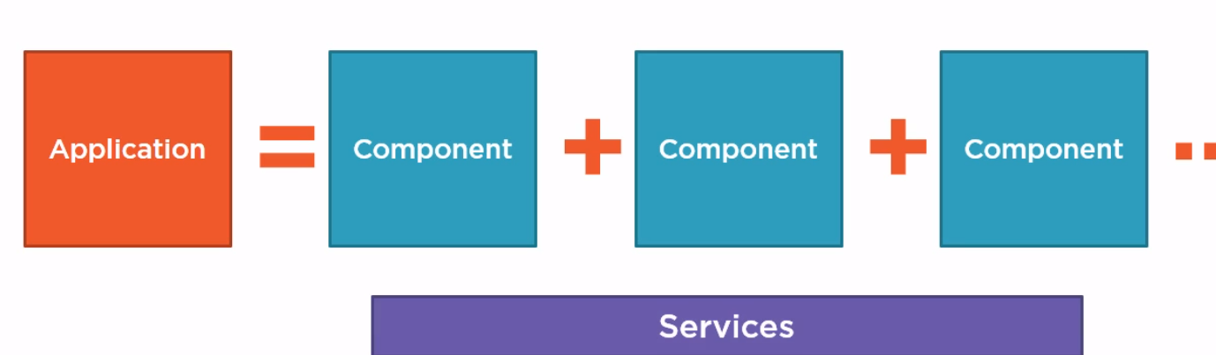

Component

Sections of UI can be broken into encapsulated components

An angular application is tree of angular components

Decroators allow us to mark a class as angular component & provide metadata that determines the component should be processed,instantiated and used at runtime.

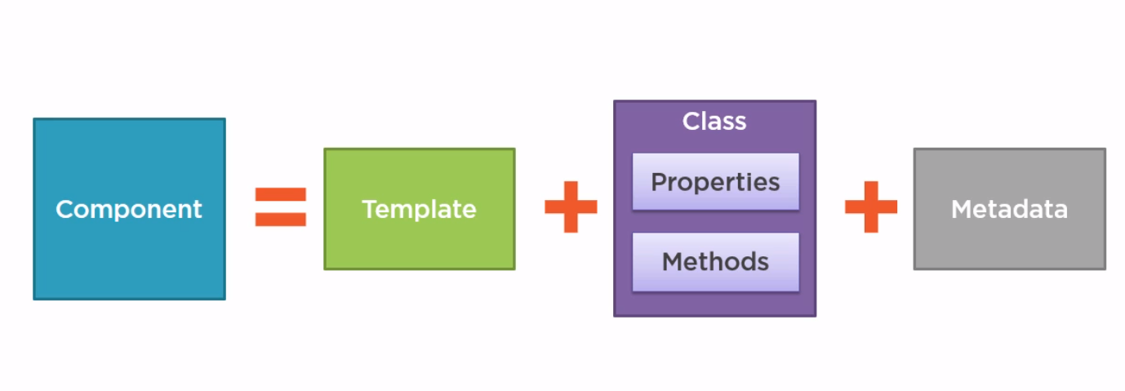

Template – html and this includes the binding and directives.

Class – properties – data elements and methods – button click methods, typescript class, code supporting the html.

Metadata – identifies class as component, extra data for angular.defined with a decrotor

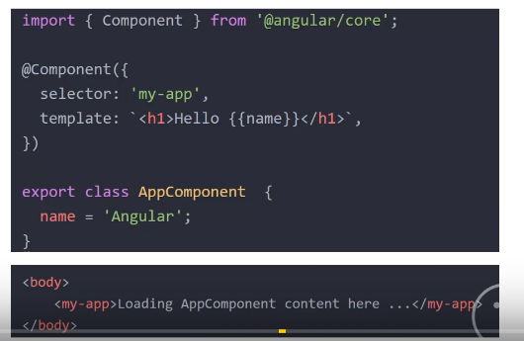

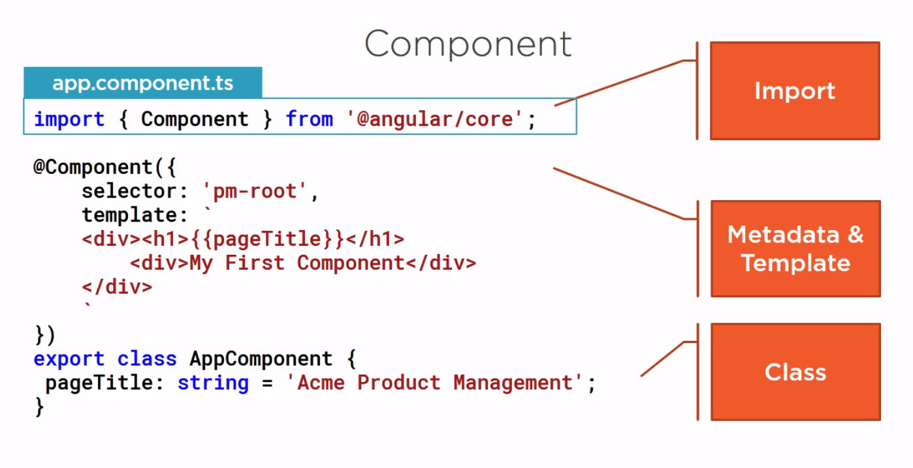

Metadata is must to determine how to instantitate the component

Decorator

Decorator is a function that adds metadata to a class or its members or its method arguments.

Decorator is javacript language feature that impelemnted in typescript.

Prefixed with @

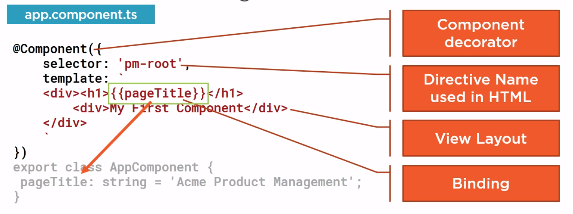

ngOnInit() in OnInit => life cycle hook event this will run when component initializes

Angular Modules

Angular modules help us organization our application to cohesive blocks of functionalities.

Root module is default

Module -> n number of components – consolidates the application feature.

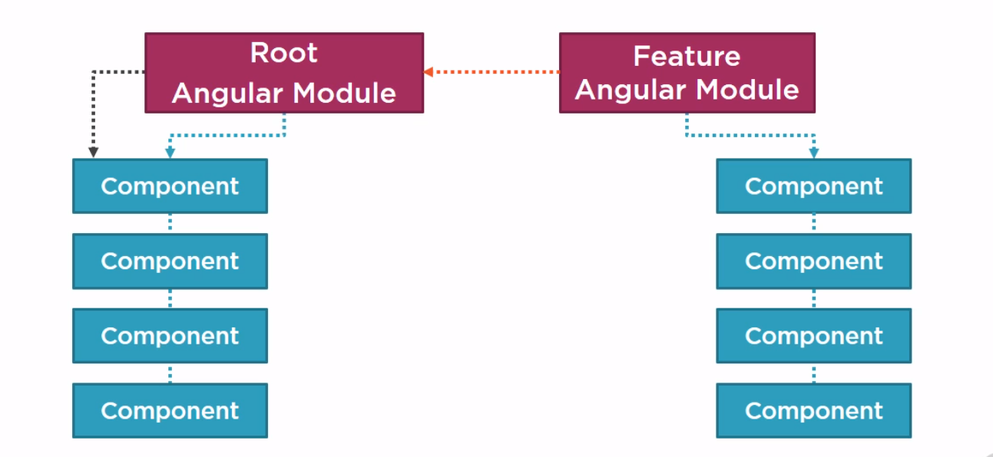

Modules

Modules helps us code organization

ES 2015 modules work – exporting class and importing class(js file in runtime class converts to js)

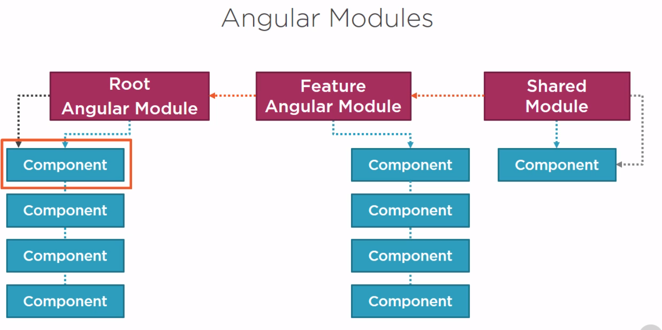

Angular modules help us organize our application to cohesive block of functionality.

Template resolution environment

NGModule – define the class as angular module.

@NgModule({

declarations: [

AppComponent,

DetailspageComponent,

PostspageComponent,

],

imports: [

BrowserModule,

FormsModule,

HttpModule,

RouterModule.forRoot(appRoutes)

],

providers: [DataService],

bootstrap: [AppComponent]

})

export class AppModule { }

Decalartion – component brlong to this module

Imports – external module belong to this module(eg browser module)

Bootstrap – start up component of application (appcomponet)

Provider – service

App Module – Declares the root application component. Component must belong to only one angular module.App module bootstraps with the app component. App module imports the system browser module.

Expose a directive. Declare in angular module or if directive declarted I another module then import the module.

Bindings

Coordinates communication between the component class and its template and often involves passing data.

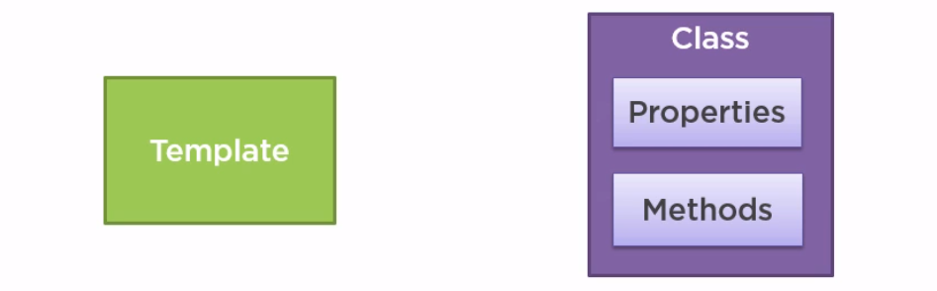

Bindings using Interpolation {{ }}

Template expression is converted to string {{}}

*ngif = ‘products && products.length’

*ngfor = ‘let product of products’

Note – no two div can have same binding element

Angular Built in directives

Like pm-products these are built in directives

*ngif *ngfor – they are directives

If expression pass – then element and children are true/false

ng if are there in the browsermodule

{{ a>10? 10:12}}

Data Bindings and Pipes

Proper binding for small values and interpolation for large values

1. Proper Binding
2. Interporlation

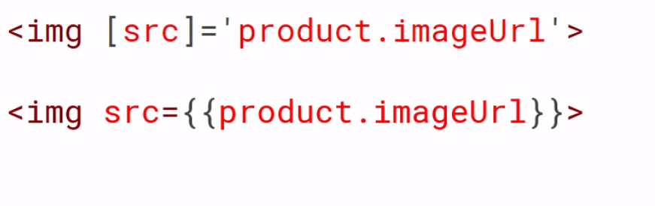

1. Event Binding



1. Two way binding



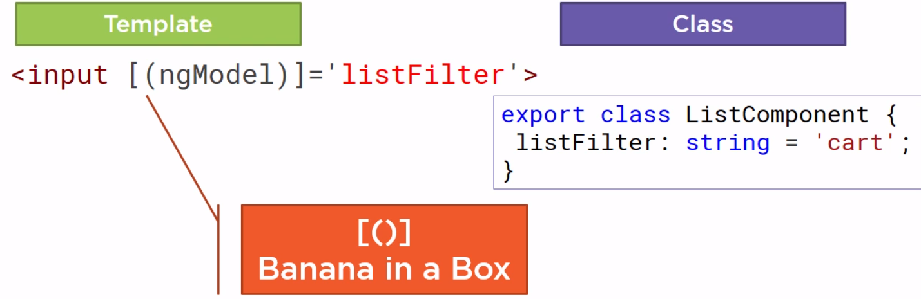

Eg for demoing this filter search box and header and filter drop down filter

1. Data Pipes

Transform bound properties before display

Built in pipes (date,number,decimal,percent,currency,json,slice)

{{productname | lowercase }}

{{product | currency}}

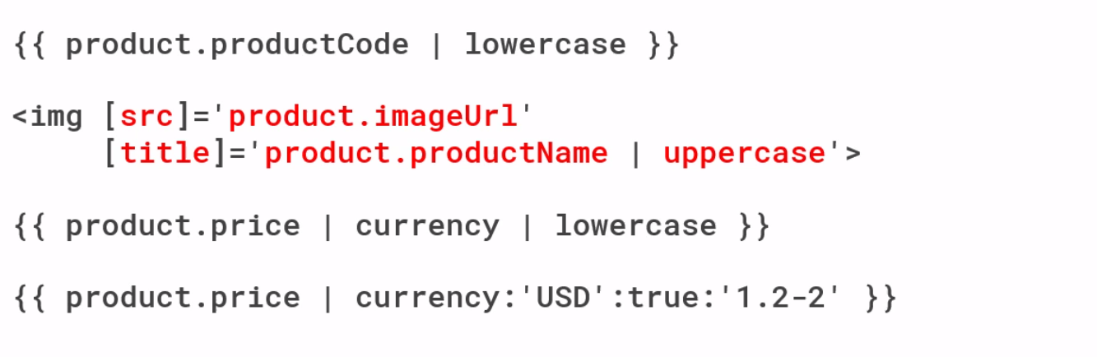

Components Behaviour

1. Strong Typing

Every property has a type and every method has a type and every method parameter has a type

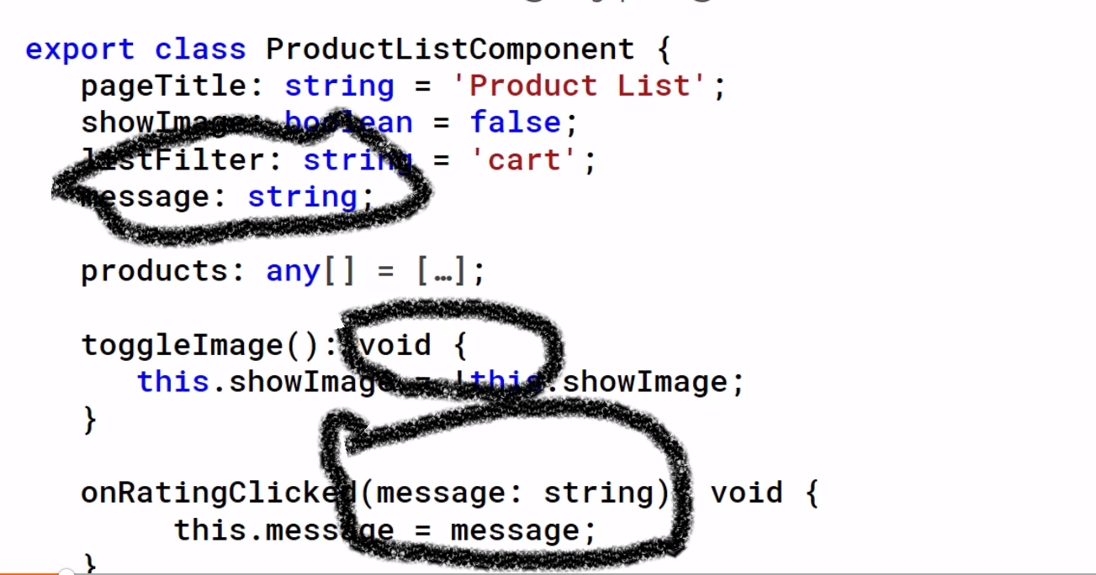

1. Interfaces

A specification identifiying a related set of properties and methods

A class commits to supporting the specification by implementing the interface

Use interface as datatype.

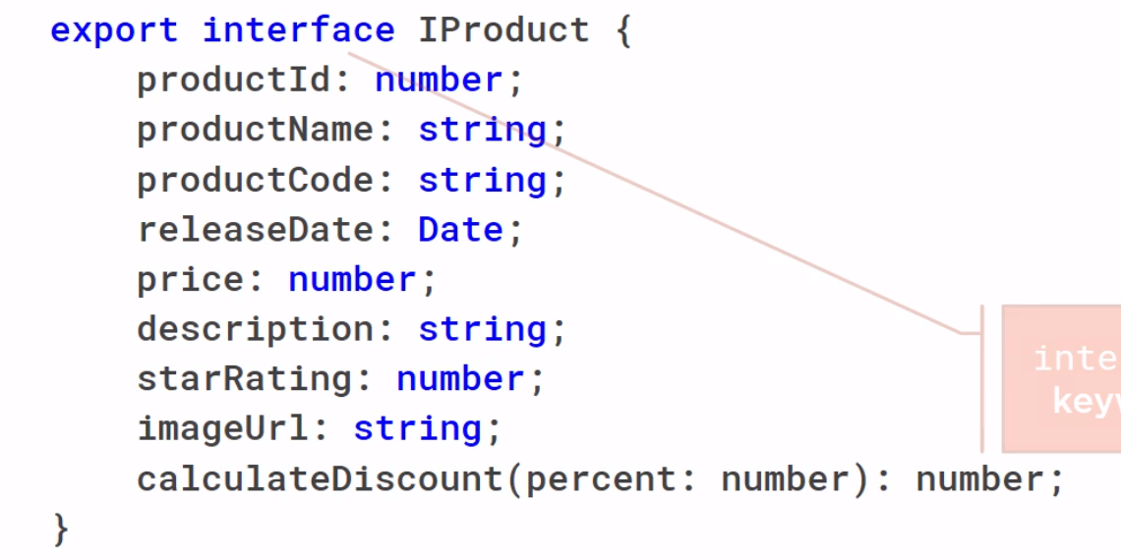

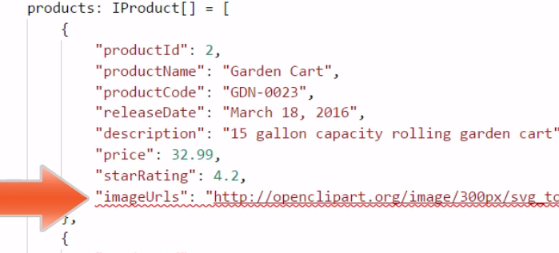

1. Enhancing component Styles

Component require unique style

We can inline the styles directly into the HTML

We can have external stylesheet and link to an index.html

1. Component Event Life cycle

OnInit – life cycle

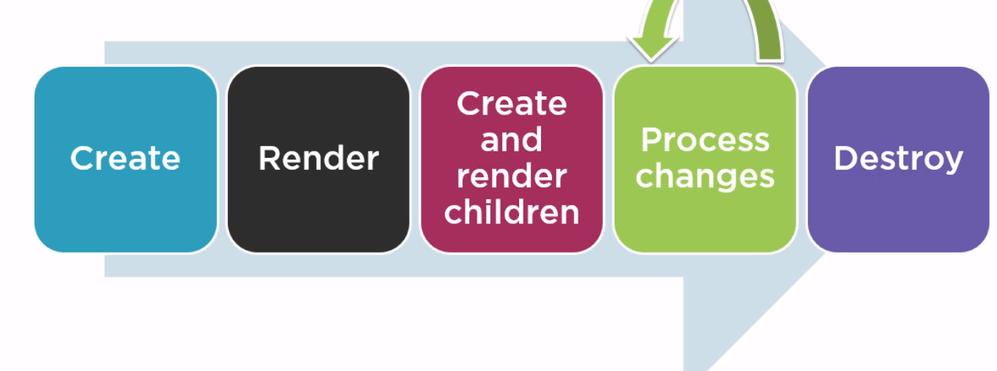

1. On Init – perform component initialization, retrieve data
2. On Changes – perform action after change to input properties
3. OnDestroy – perform clean up

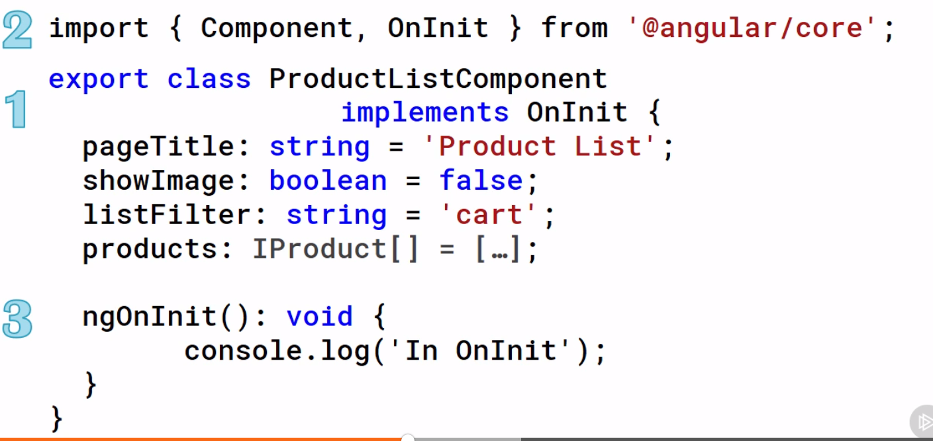

1. Custom Pipes

Transfer bound properties before it display

Eg: gn-20000 should replay gn20000 here the – should be displayed

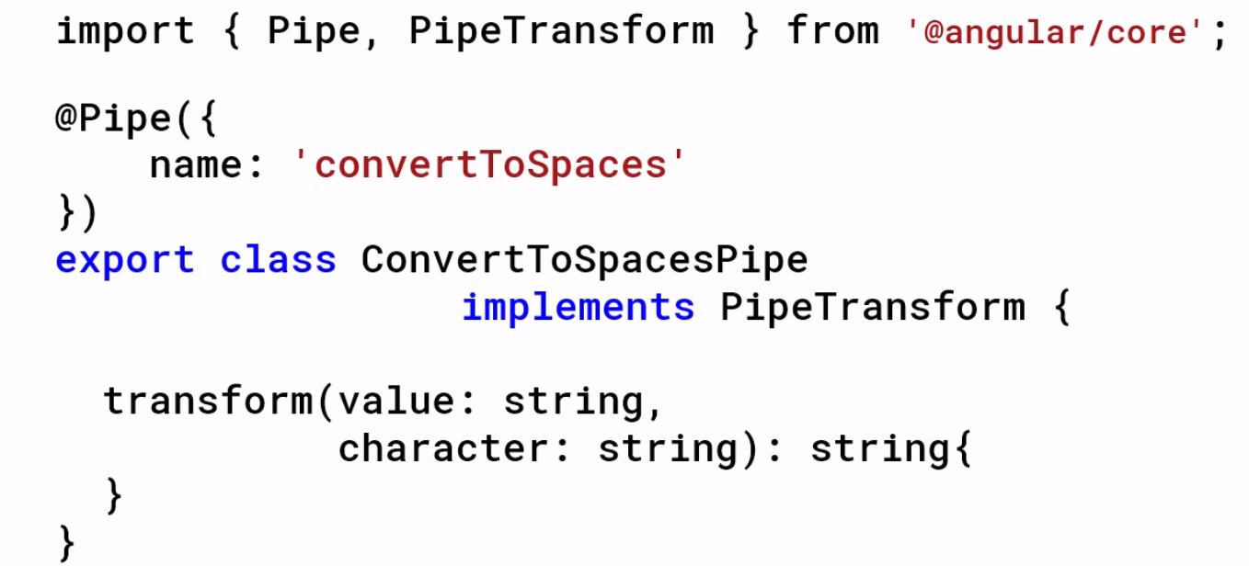

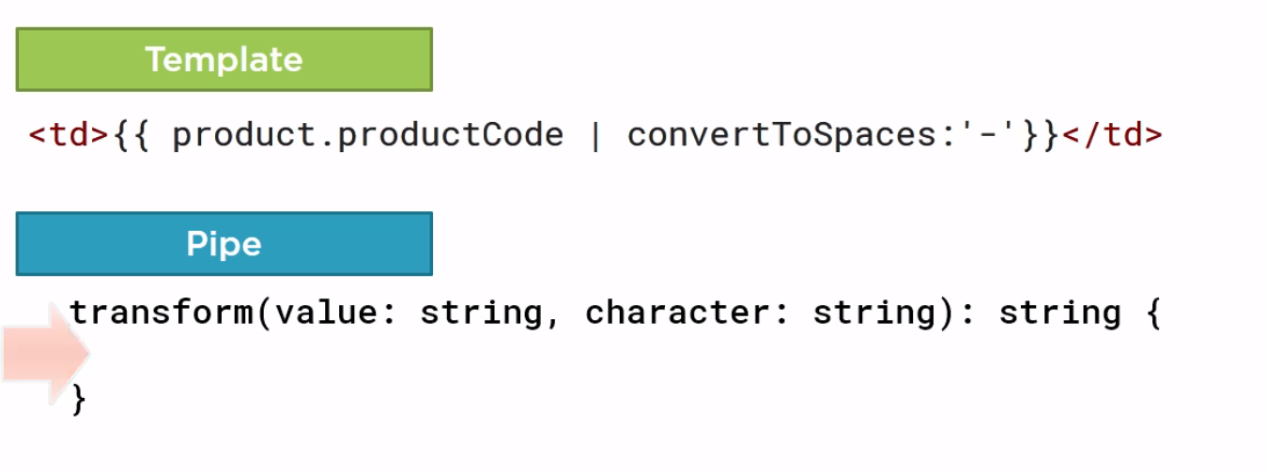

Add this pipe to the angular module

Add this in decleration of app.module

1. Filtering

For smaller list go for pipe else go for get set.

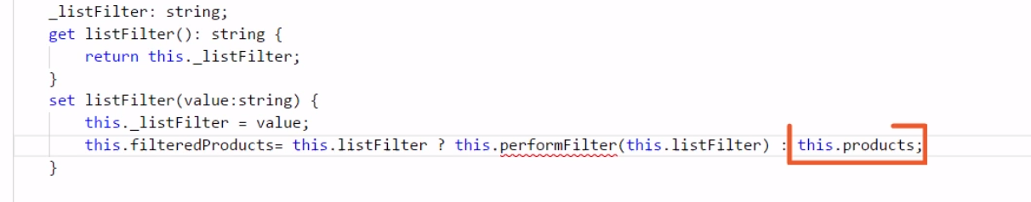

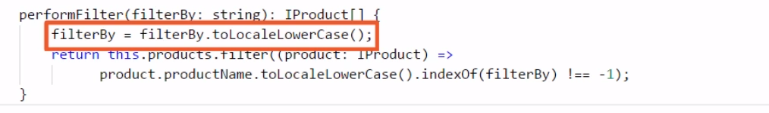

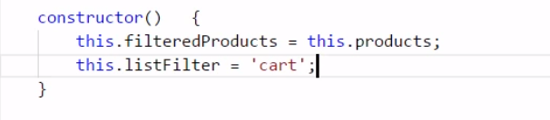

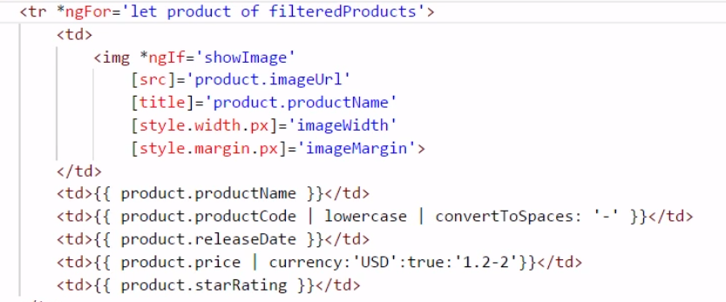

Safe navigation operator

If the value is null or empty product?.productName

You wont see undefined property error.

This wont work with ngmodel two way binding

The better way is ngif

Nesting Components

Its template only manages a fragment of a larger view. It has a selector. It optionally communicates with the communicator.

Eg: star rating component inside product detail component

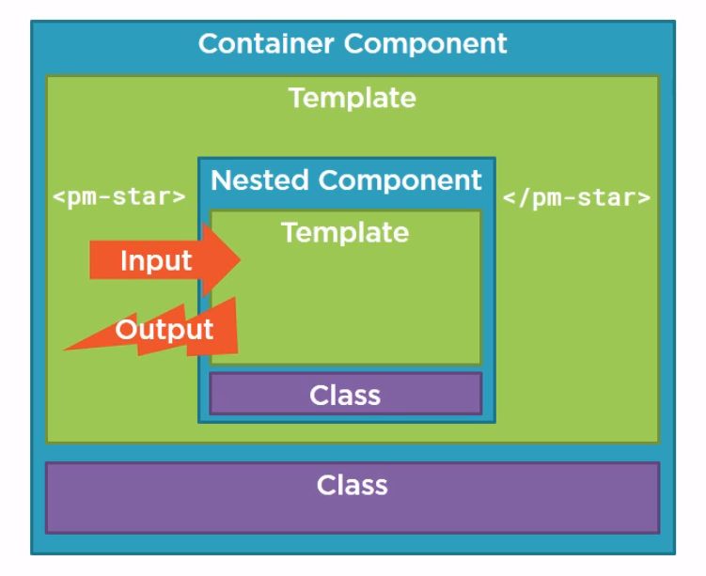

Recives using Input() sending out using Output event

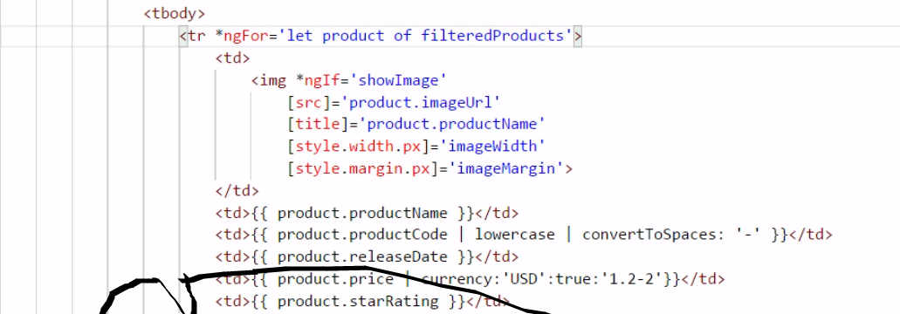

Put star component and use it

Put star component in shared

Services

Classes that send data and functionality across components

A service is class with focused purpose. Used for features that are independent from any particular component. Provide shared data or logic across component. Encapsulate external componets.

Don’t repeat , ideal place for ajax calls

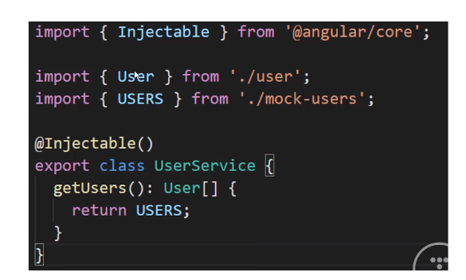

Eg: products service,logging service

1. How services works & dependency injection works

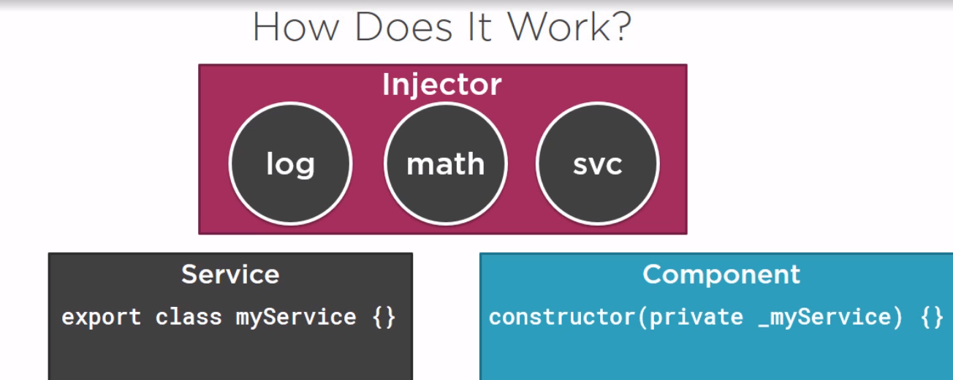

Component can create instance of service and can use it (let svc = new myservice()) but instances are local only to the component and we cant share data and other resources and testing is tough with this.

Instead we can register the service with angular . Angular then create single instance of class called singleton and holds on it. Angular provides built in injector we register our services with injector which maintains as container for created service instances. Injector create and manage the single instance.

If the component need the service pass the service in constructor

constructor(private dataservice: DataService) { }

Any data or logic in that instances you shared all the classes use it. It allowed sharing of resources.

Dependency injection – is coding pattern in which class receives the instances of objects it needs (called dependenices) from an external source rather than creating them itself.

Here angular injector is the external source.

1. Building a service

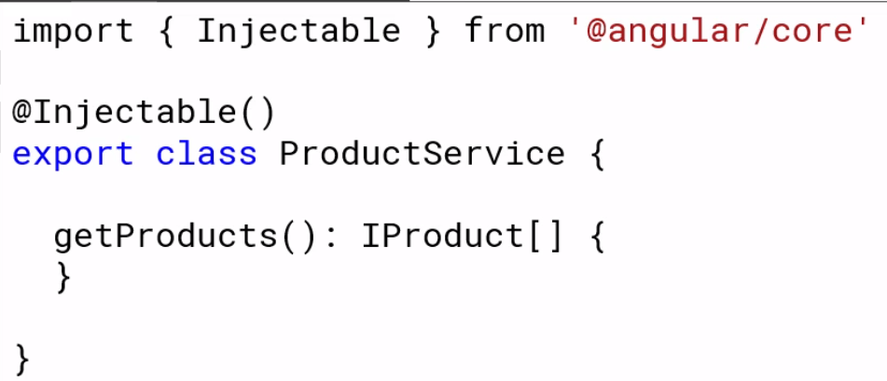

1. Registering a service

Register a provider = add this in the angular module so we can use it all over the application.

We register the service with the angular injector. The angular injector provides service instances to any class that defines at dependencies.

You can register the provider in the component or angular module metadata.

Register at component will injectable to component and its children

Register at app.componet will also work. Only one copy be there.

Register in angular module injectable everywhere in the application.

If you do it at both places. Then it will maintain two copies of the instance in the injector.

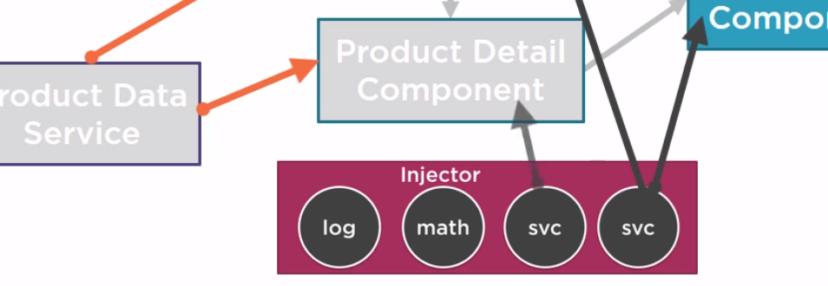

1. Injecting the service

In the constructor we will inject the service.

Constructor(private service: dataservice) {

}

Retrieving data using HTTP

1. Observables - help manage asynchronous data. Treat events as a collection. An array whose items arrive asynchronously over time.

Operators used in observables- operators are method of observables that compose new observables. It transforms the source observable in some way. Process each value as it is emitted.

Ex: map,filter,take,merge

Map(x=>10*x)

Observable is is lazy.

Observable can be cancelled by unsubscribing

Emits multiple value over time

Getproducts() : Observable<Iproduct[]) {

Return this._http.get<Iproduct[]>(http:google.com)

}

Observable are async by default

1. Reactive Extensions – to fetch data.

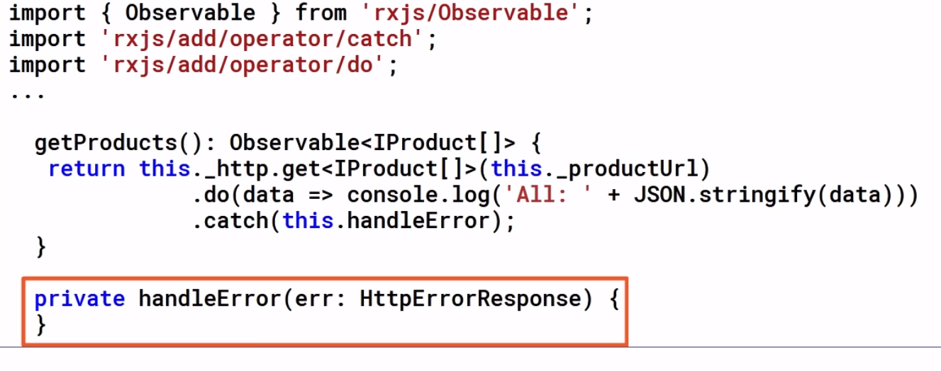

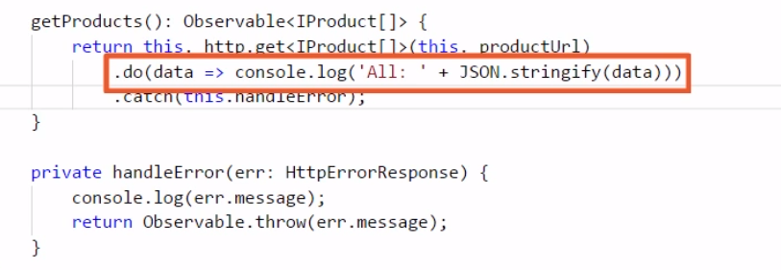

1. Subscring to an observable

Once we rechieve the data. Do this

x.subscribe(valuefun,errorfun,completefun)

let sub = x.subscribe(valuefun,errorfun,completefun)

x – observable

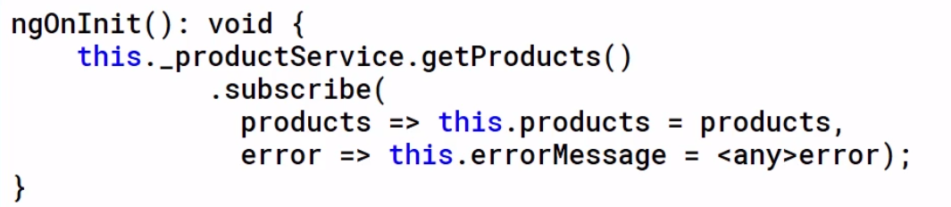

Do when success, fail, completion

Let sub = x.subscribe() – can cancel the observable.

Navigation and Routing Techniques

Route to multiple views

1. Configure a route for each component - Do this in your app.component

<li><a routerLink ="/posts"> Posts</a></li>

1. Define Options and actions and Tie a route to each option/action In the app.module do the routing configuration

// routing configuration

const appRoutes: Routes = [

{path: 'details', component: DetailspageComponent},

{path: 'posts', component: PostspageComponent},

{path: 'productlist', component: ProductlistComponent},

{path: 'usercomp', component: UsercompComponent},

];

1. Import the route constants

import {RouterModule, Routes} from '@angular/router';

imports: [

BrowserModule,

FormsModule,

HttpModule,

HttpClientModule,

RouterModule.forRoot(appRoutes)

],

1. Based on the route link it will look for app routes and display the content in route outlet (container) in app.component.

<!-- router outlet to display -->

<router-outlet></router-outlet>

1. Different routing definitions

Products/id – <http://googlecom/add/2>

‘’ – default route and match the path and redirect to welcome route

** - wild card path. If request url is not match anyting 404

Order is important. Routing will match this in the order

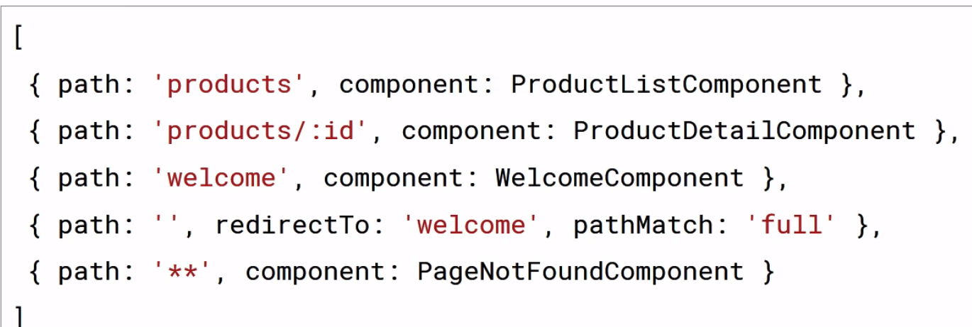

1. Navigation can happen through menu option, link,image, button click that activates or navigates the route.
2. Typing the url in the address bar or bookmark.
3. Or browser forward or back button.

Overall routing works like this. -> when user navigate to the link <http://localhost/products> router link in the app.component (<a [routerlink] =[‘products)] product list ). The router searches through list of valid definitions and **picks the first match.** Router locates or creates the component associated with the route. Then the component view is injected to the router outlet <router-outlet>. Then the page is displayed here

More on routing –

1. Passing parameters to route <http://localhost/products/1>

Configure route



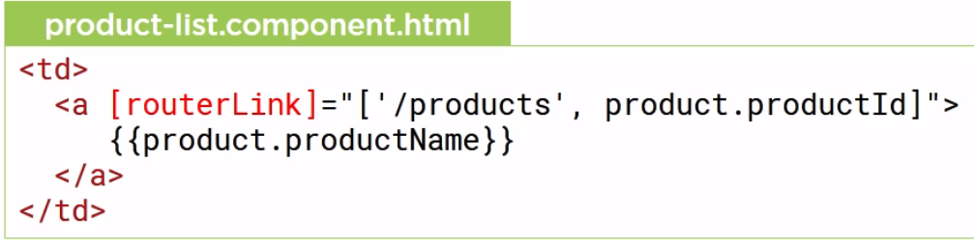



Retrieve parameters from route

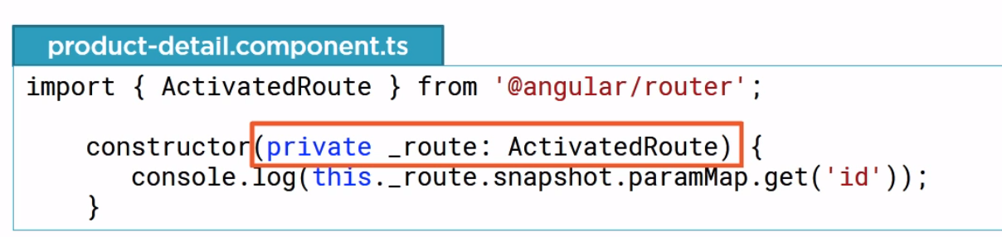snapshot for regular parameter for next option use observable

Route activation from html or code behind

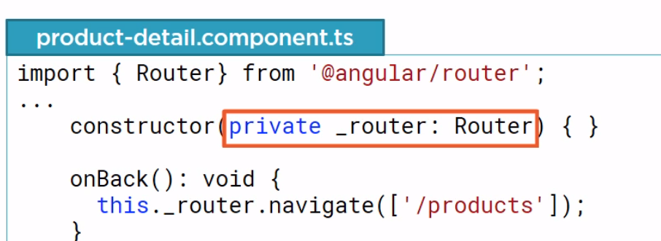

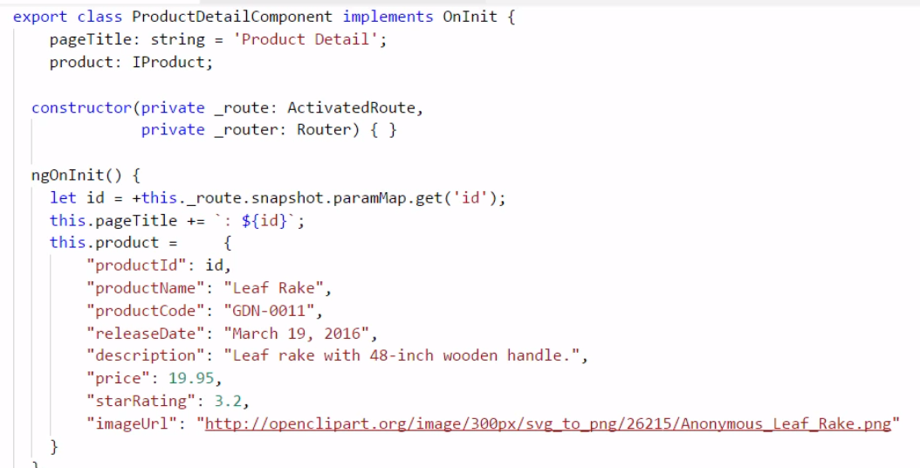

1. Protecting the routes with guards

CanActivate – guard navigation to a route

CanDeActivate – guard navigation from a route

Resolve – pre fetch data before activiating a route

canLoad – prevent asynchrounous routing

guard as service

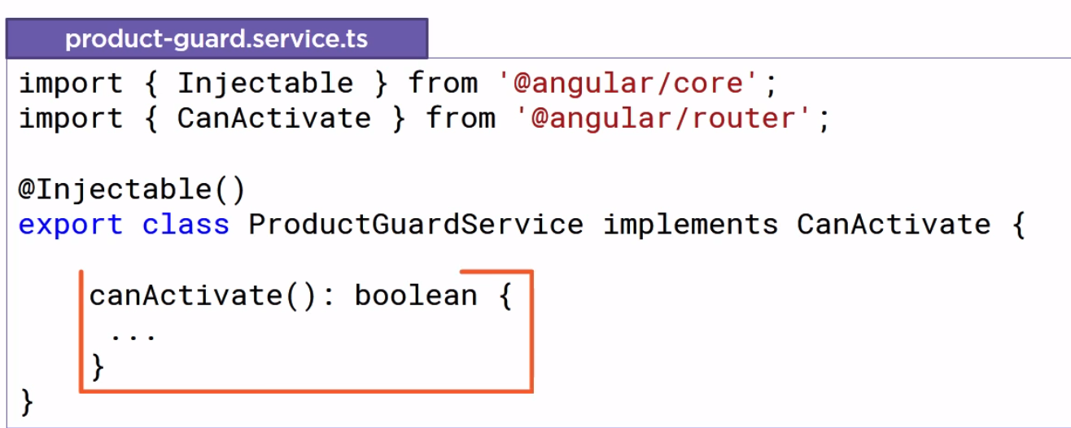

True to activate the route or false to not activate

Guard are service need to register in the angular module in providers

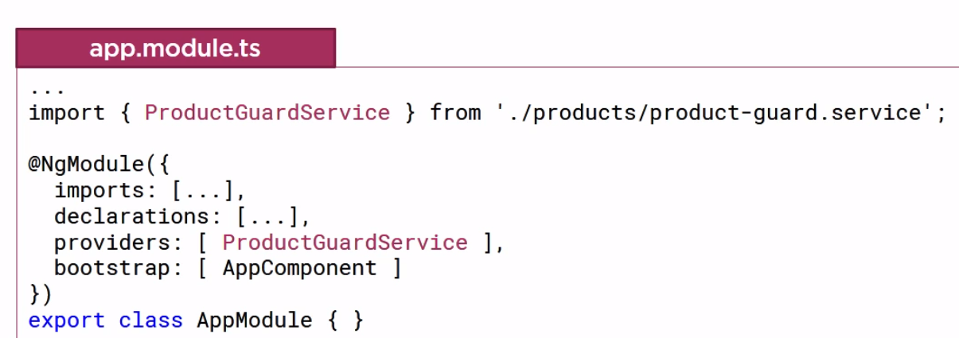

Add the guard to the product detail

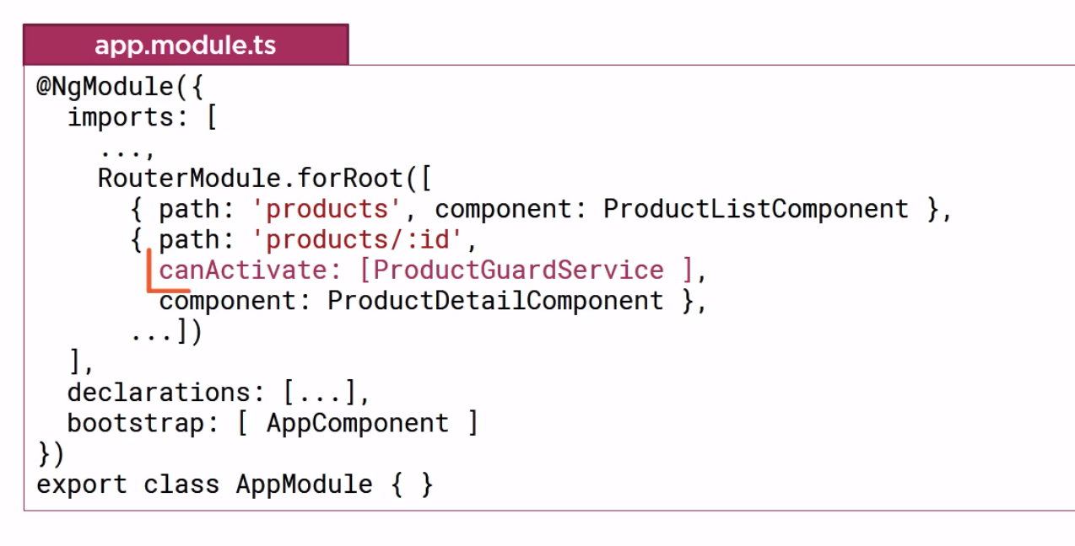



The guard will execute before the route is activated

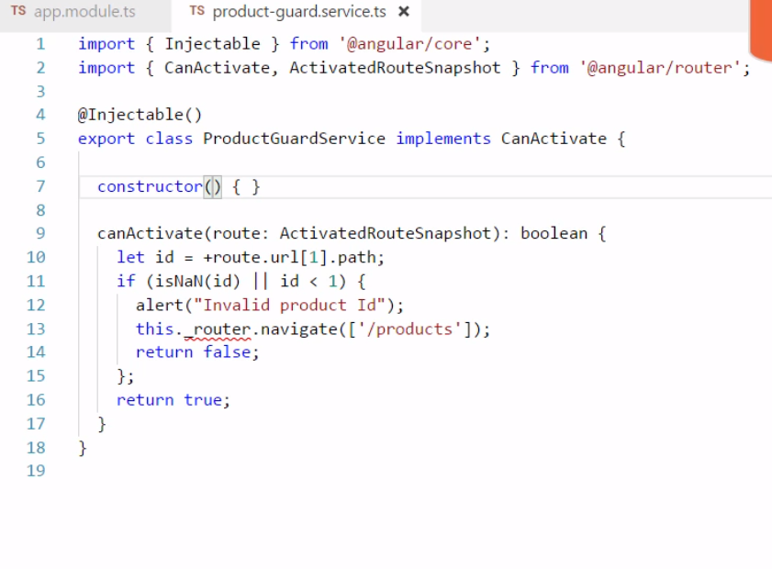

Angular Modules

Angular module is a class with ng module decorator

It is purpose is to organize pieces of our application. Arrange them into blocks. Extend our application with capabilities from external libraries. Provide a template resolution environment. Aggregate and export them back. (like browser module)

Angular module declares each component, pipe, directive that it manages.

Angular module bootstrap our root application.

Angular module exports component,directive,pipe, other angular module

Angular module imports other module

Angular module can register service provider

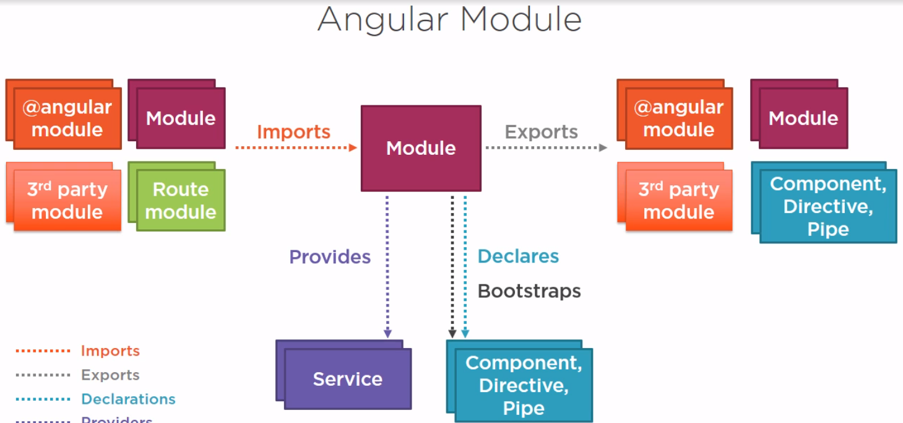

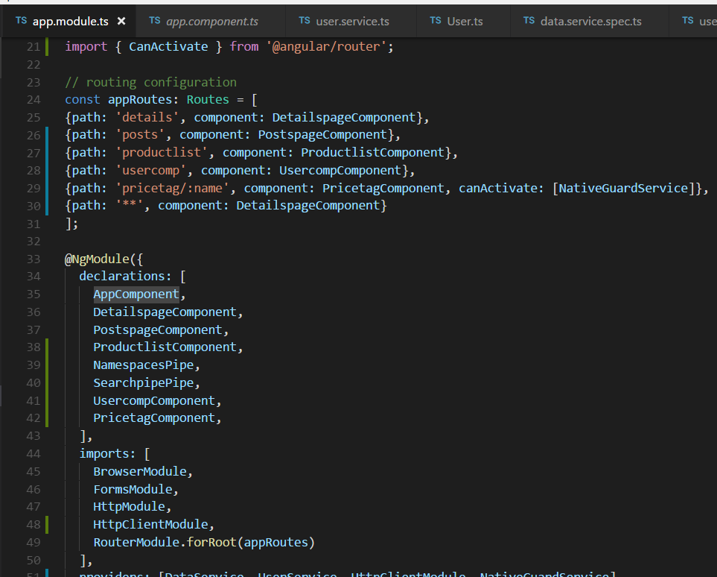

Template resolution environment –

Here product list component uses ngmodel so we exported in the model from forms module. Also it uses star component so we need to export it

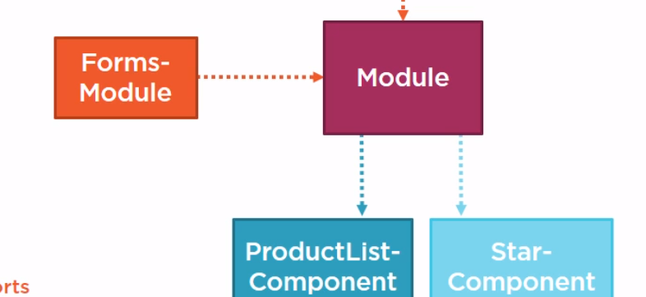

Or we need to export the star compont using another module

The concept here is exither you need to export the component directly OR you can export the module that defines the component and use it.

Best way is in same module you can export the component directly if different module export the module.

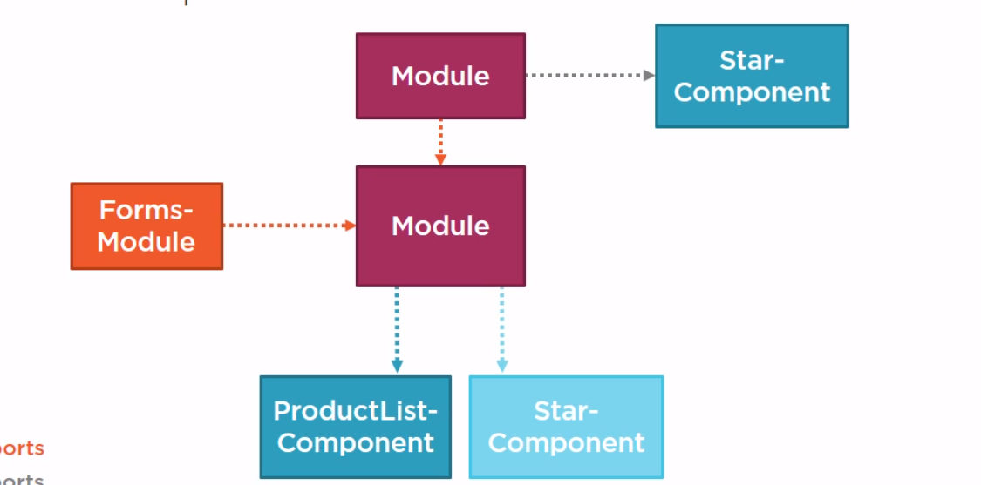

You need to use one or the other not both component export or module exporting

1. Bootstrap array

Root application module bootstrap the root application component provide the directive used in index.html.

This is starting point of application.

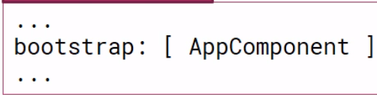

The bootstrap array should only be used in the root application module.

1. Declaration Array

Every component, pipe,directive we create should be declared in angular module.

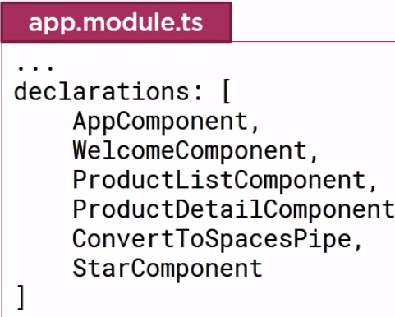

* Every component, directive and pipe we create has to belong to only one angular module.
* Only declare component, pipe and directive
* Never redeclare component, directives or pipes that belong to another module
* All declared component, directive, pipe is private by default. They are accessible to another component, directive and pipe declared in same module.
* The angular environment provides the template resolution environment for its component templates. (use the directive either in same component directive or exported from another angular module) egL start component

1. Exports Array

* we can export any component, directive and pipes in the module.
* We can also reexport existing angular module. Eg: httpmodule, formsmodule
* We can reexport any third-party module.
* We can reexport our own module.
* Reexporting is for sharing modules features
* We can reexport something without importing its first.
* Never export a service

export class AppModule { }

1. Imports Array

* Angular module can be extended by importing In another module
* We can extend our own application to extend our application with additional capabilities
* imports: [

BrowserModule,

FormsModule,

HttpModule,

HttpClientModule,

RouterModule.forRoot(appRoutes)

],

* importing a module makes available any exported componets, directives and pipes from that module. Forms module => app module
* only import needed module needs
* importing a module that does not provide access to its imported modules

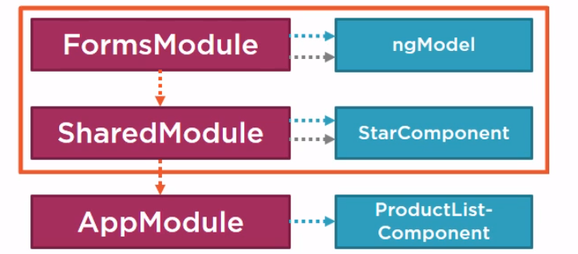

No multi-level inheritance

1. Providers array

Any service provider added to the provider array are registered at the root of the application

Don’t add service to the provider array of the shared module.

Consider building it once in coremodule and import it once in the app module.

Service can be registered a the module level or component level

Routing guard must be added to the provider array of an angular module.

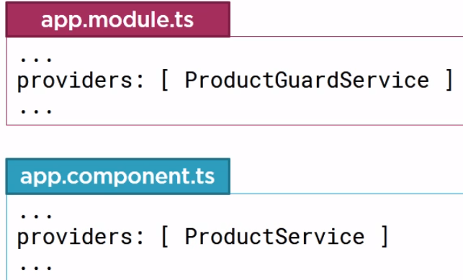

1. Features module

Without separation of concerns –

Hard to manage

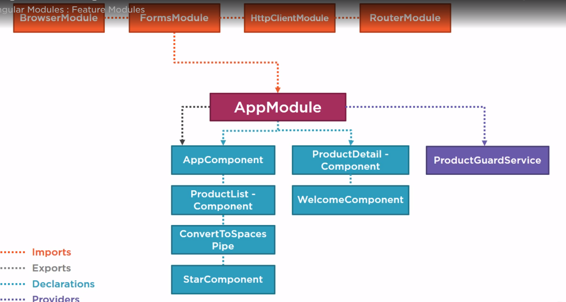

Feature module –

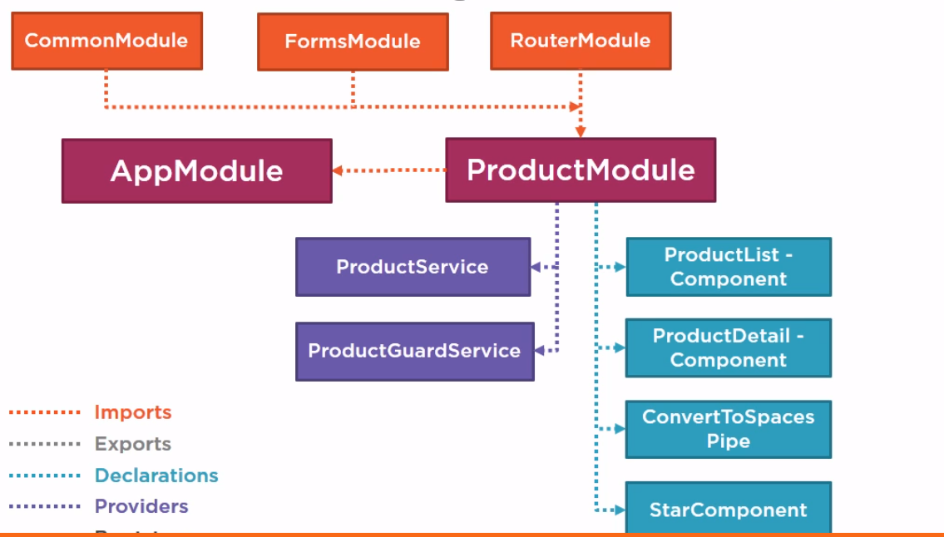

Doimporting product module in app module

Steps to migrate one module to another feature module

1. Move all the declaration and their imports
2. Import all the modules and their imports
3. Import routermodule.forchild ( routes to product)

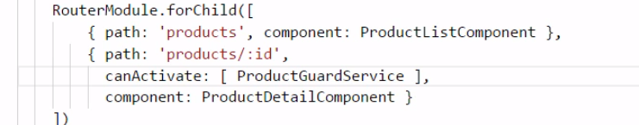

RouterModule.ForRoot -> registers router service, declares router directive and exposes configured routes

Routermoudule.forchild – declares router directives, exposes configured routes

1. Moving the product service to feature module is optional either it can be at the root app component.
2. Shared module

It allows us to selectively aggreagate our reusable components and external modules and reexport them in consolidate way.

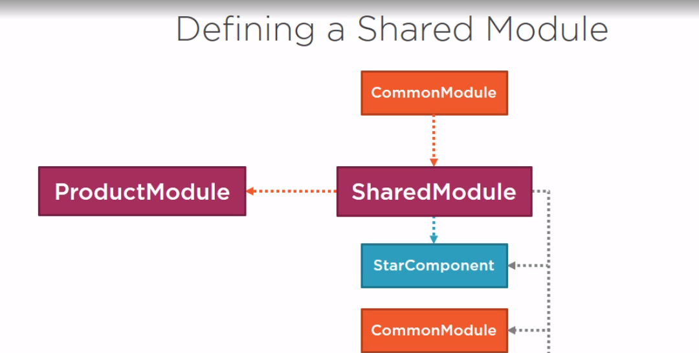

Move all the forms module and router module to shared module

Clean program code.

Sample Application Architecture

Application has Product list , product list detail page, welcome page

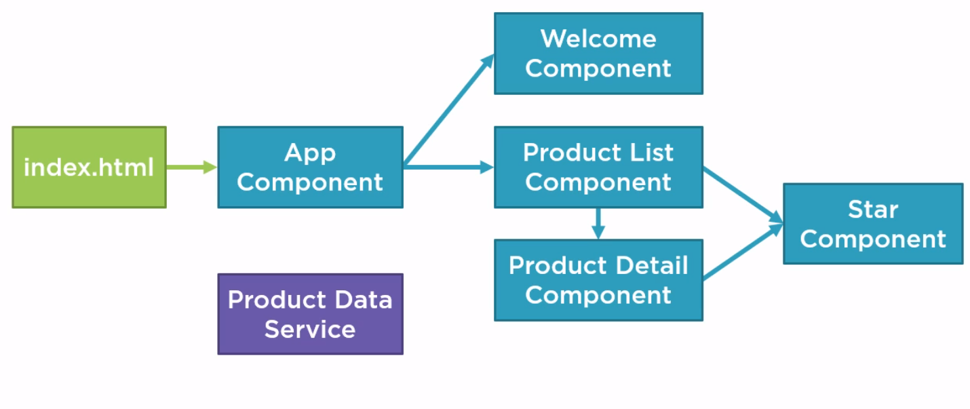

@angular/Core – package

Import {Component} from ‘@angular/core’;